Instructions for Creating a Quiz in Google Forms
Governments are welcome to use their preferred internal or external quiz services when implementing the Cyber Awareness Training course. One option for those who do not have a preferred service is using Google forms to create and disseminate the Cyber Awareness Training quiz to staff. Please note, you will need a Google account in order to create a quiz using Google forms.
We suggest putting all the quiz questions into a single quiz and having staff scroll through the quiz as they complete each module.
To create a quiz in Google forms:
- In Google Forms, click Plus .
- At the top right, click Settings .
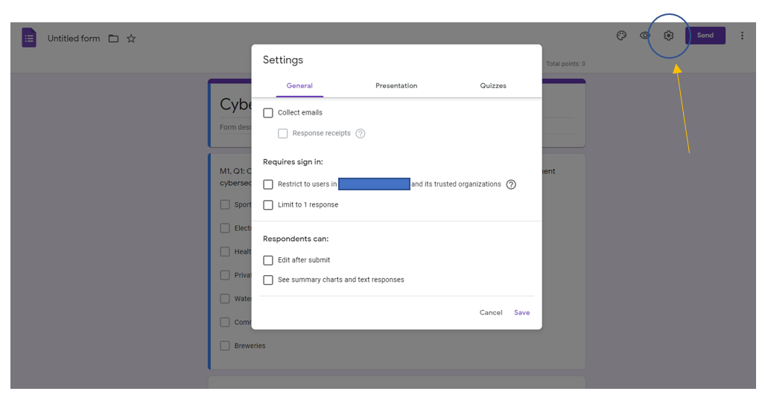
- Click Quizzes Make this a quiz. We suggest not restricting to users in a specific organization because it may make it difficult for intended colleagues to access the form.
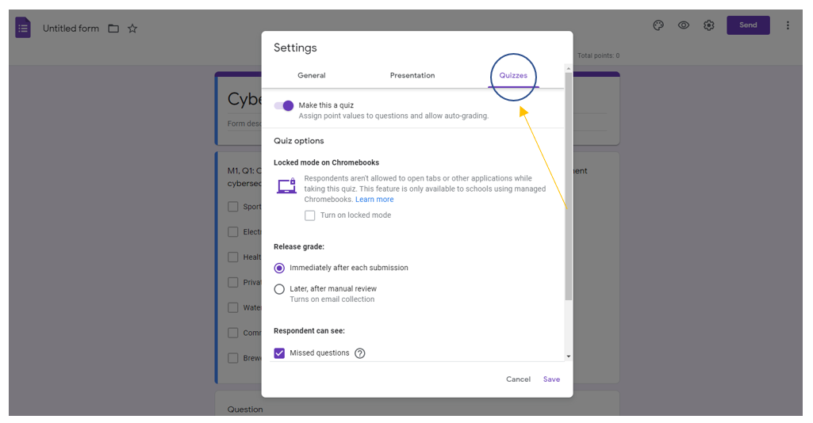
- Add your first question. Make sure you indicate which module and which question you are referencing. For example M1, Q1 would represent Module 1, Question 1.

- Depending on the question format (Multiple Choice, Check Boxes, etc.) select the style for the question in the top right box (shown below as Multiple choice). Add the questions from each of the Modules.
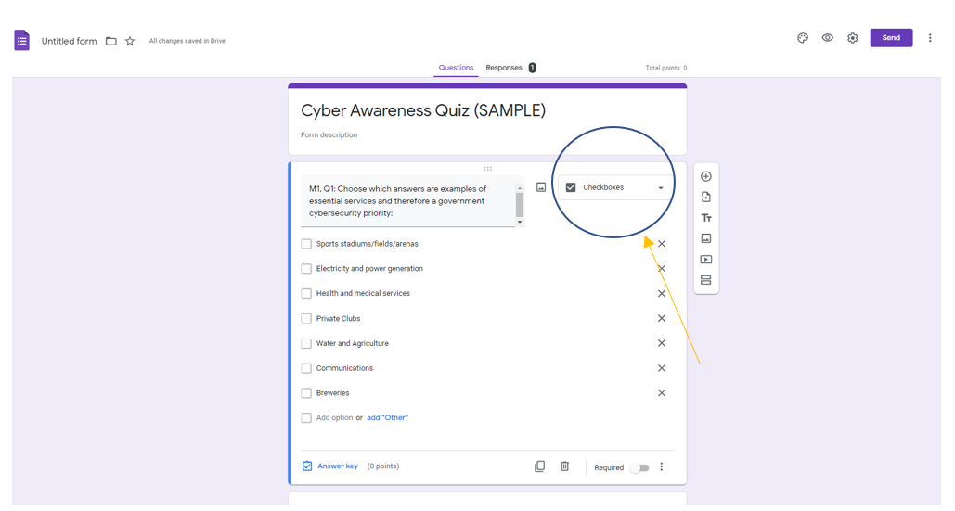
- After you have input the questions and possible answers, select “Answer key” in the bottom left corner of the form.
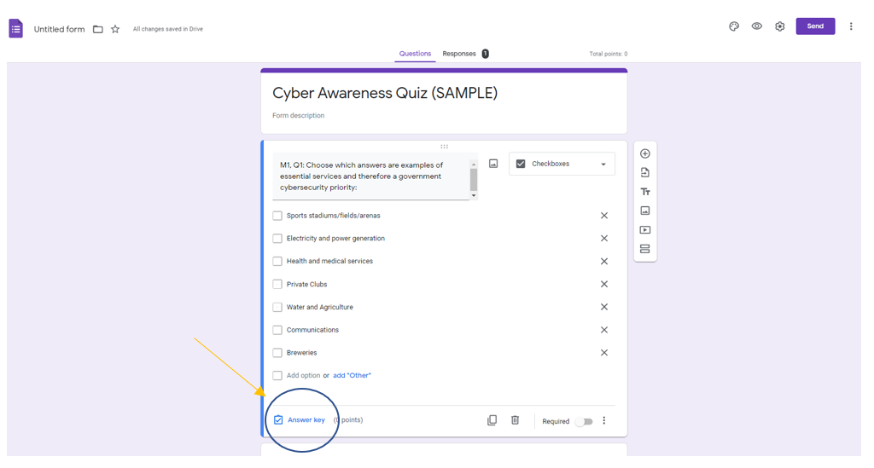
- Check the boxes of all of the correct answers.
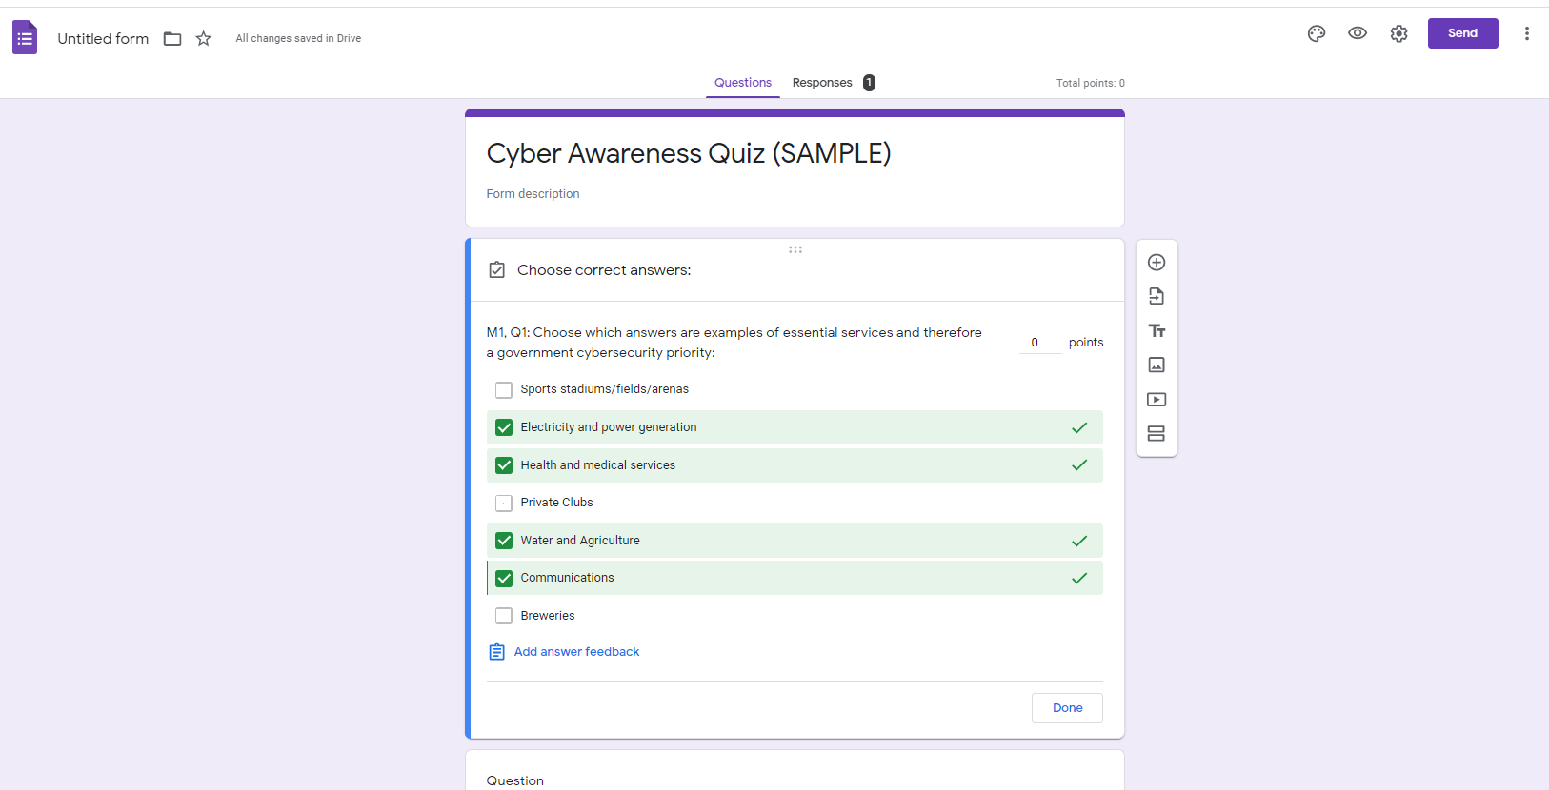
- To add additional questions select the (+) to the right of the question.
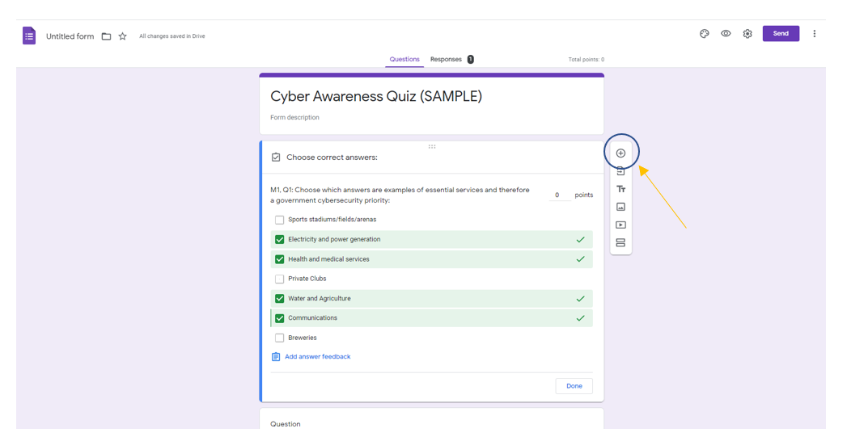
- After you have inserted all the questions and answers, select “Send” in the top right corner of the screen. In the “Send form” select the link icon to access a link to send to staff to complete the quiz.
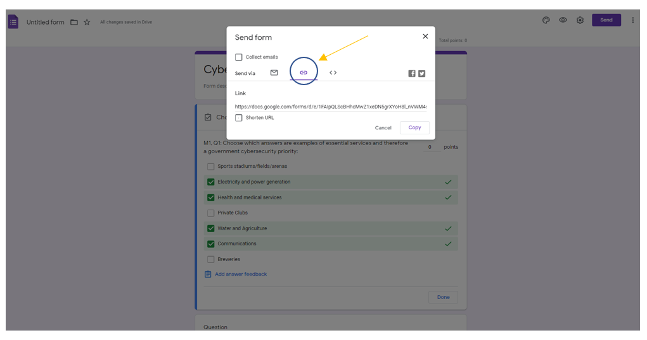
- To review responses, click “Responses” at the center top of the form.
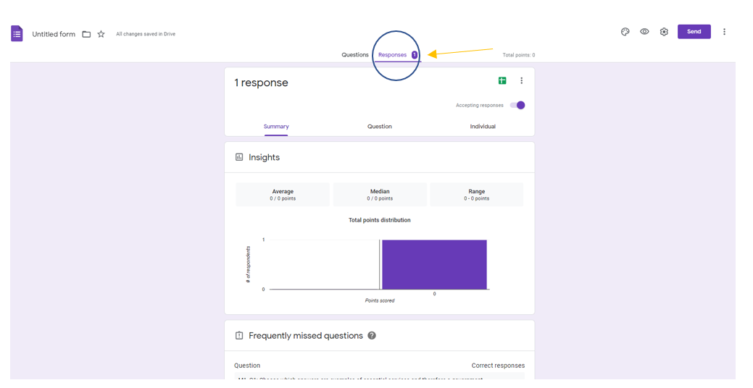
- Click Save.

